**School Management System**

A School Management System is an information management system for educational institutions to manage all student's data. School Management System allows complete control of the different activities that includes class, courses, subjects, etc.

**ERD Diagram:**

**Using vertabelo I have created a Relation Schema:**

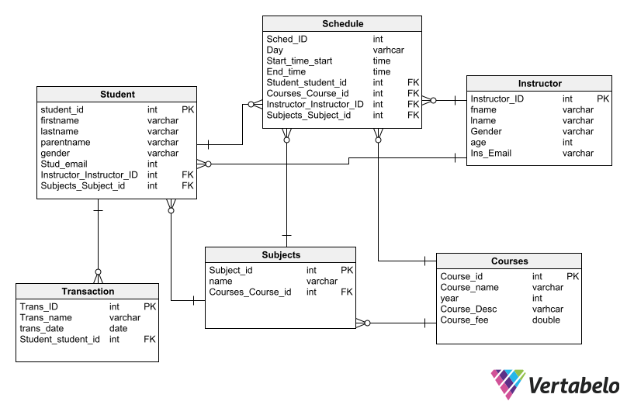

**Tables and Data inserted and I have generated a pdf for table details in vertabelo:**

CREATE TABLE Courses (

Course_id int NOT NULL DEFAULT 100,

Course_name varchar NOT NULL DEFAULT 100,

year int NOT NULL,

Course_Desc varhcar NOT NULL DEFAULT 100,

Course_fee double NOT NULL,

CONSTRAINT Courses_pk PRIMARY KEY (Course_id)

);

-- Table: Instructor

CREATE TABLE Instructor (

Instructor_ID int NOT NULL,

fname varchar NOT NULL,

lname varchar NOT NULL,

Gender varchar NOT NULL,

age int NOT NULL,

Ins_Email varchar NOT NULL,

CONSTRAINT Instructor_pk PRIMARY KEY (Instructor_ID)

);

-- Table: Schedule

CREATE TABLE Schedule (

Sched_ID int NOT NULL,

Day varhcar NOT NULL,

Start_time_start time NOT NULL,

End_time time NOT NULL,

Student_student_id int NOT NULL,

Courses_Course_id int NOT NULL,

Instructor_Instructor_ID int NOT NULL,

Subjects_Subject_id int NOT NULL

);

-- Table: Student

CREATE TABLE Student (

student_id int NOT NULL,

firstname varchar NOT NULL,

lastname varchar NOT NULL,

parentname varchar NOT NULL,

gender varchar NOT NULL,

Stud_email int NOT NULL,

Instructor_Instructor_ID int NOT NULL,

Subjects_Subject_id int NOT NULL,

CONSTRAINT Student_pk PRIMARY KEY (student_id)

);

-- Table: Subjects

CREATE TABLE Subjects (

Subject_id int NOT NULL,

name varchar NOT NULL,

Courses_Course_id int NOT NULL,

CONSTRAINT Subjects_pk PRIMARY KEY (Subject_id)

);

-- Table: Transaction

CREATE TABLE Transaction (

Trans_ID int NOT NULL,

Trans_name varchar NOT NULL,

trans_date date NOT NULL,

Student_student_id int NOT NULL,

CONSTRAINT Transaction_pk PRIMARY KEY (Trans_ID)

);

-- foreign keys

-- Reference: Schedule_Courses (table: Schedule)

ALTER TABLE Schedule ADD CONSTRAINT Schedule_Courses FOREIGN KEY Schedule_Courses (Courses_Course_id)

REFERENCES Courses (Course_id);

-- Reference: Schedule_Instructor (table: Schedule)

ALTER TABLE Schedule ADD CONSTRAINT Schedule_Instructor FOREIGN KEY Schedule_Instructor (Instructor_Instructor_ID)

REFERENCES Instructor (Instructor_ID);

-- Reference: Schedule_Student (table: Schedule)

ALTER TABLE Schedule ADD CONSTRAINT Schedule_Student FOREIGN KEY Schedule_Student (Student_student_id)

REFERENCES Student (student_id);

-- Reference: Schedule_Subjects (table: Schedule)

ALTER TABLE Schedule ADD CONSTRAINT Schedule_Subjects FOREIGN KEY Schedule_Subjects (Subjects_Subject_id)

REFERENCES Subjects (Subject_id);

-- Reference: Student_Instructor (table: Student)

ALTER TABLE Student ADD CONSTRAINT Student_Instructor FOREIGN KEY Student_Instructor (Instructor_Instructor_ID)

REFERENCES Instructor (Instructor_ID);

-- Reference: Student_Subjects (table: Student)

ALTER TABLE Student ADD CONSTRAINT Student_Subjects FOREIGN KEY Student_Subjects (Subjects_Subject_id)

REFERENCES Subjects (Subject_id);

-- Reference: Subjects_Courses (table: Subjects)

ALTER TABLE Subjects ADD CONSTRAINT Subjects_Courses FOREIGN KEY Subjects_Courses (Courses_Course_id)

REFERENCES Courses (Course_id);

-- Reference: Transaction_Student (table: Transaction)

ALTER TABLE Transaction ADD CONSTRAINT Transaction_Student FOREIGN KEY Transaction_Student (Student_student_id)

REFERENCES Student (student_id);

**Data Inserted into Tables:**

**Courses Data**

insert into courses values(1,"Cloud",2021,"Related to AWS",1300);

insert into courses values(2,"Database",2021,"Related to Database Management System",1000);

insert into courses values(3,"DataScience",2021,"Related to Data Analysis",1500);

**Instructor Data:**

insert into instructor values(11,"George","Kal","male",40,"george@gmail.com");

insert into instructor values(12,"maali","joe","male",45,"mallijoe@gmail.com");

insert into instructor values(13,"karry","james","male",50,"james@gmail.com");

**Schedule Data:**

insert into schedule values(1,"Monday", '12:00:00', '13:00:00',1,1,11,1);

insert into schedule values(2,"Tuesday", '12:00:00', '13:00:00',1,2,13,3);

insert into schedule values(3,"Wednesday", '12:00:00', '13:00:00',1,3,12,2);

insert into schedule values(1,"Thursday", '12:00:00', '13:00:00',1,1,11,1);

insert into schedule values(1,"Friday", '12:00:00', '13:00:00',1,1,11,1);

**Student Data**

insert into student values(1,"saikrishna","dubak","Shiva","male","saikrishna@gmail.com",11,1);

insert into student values(2,"teja","Ravi","Notani","male","ravi@gmail.com",12,3);

insert into student values(3,"Manoj","Jakana","Natsha","male","manoj@gmail.com",11,2);

insert into student values(4,"Ramya","Lekanav","Hari","female","Ramya@gmail.com",13,3);

**Subjects Data:**

insert into subjects values(1,"Cloud Computing",1);

insert into subjects values(2,"AWS",1);

insert into subjects values(3,"Data Analysis",3);

insert into subjects values(4,"DBMS",2);

**Transaction Data:**

insert into transaction values(1,"Course_fee",17/12/2021,1);

insert into transaction values(2,"Course_fee",15/08/2021,2);

insert into transaction values(3,"Course_fee",07/04/2021,3);

insert into transaction values(4,"Course_fee",13/12/2021,1);

**Screen Shots of All Tables and Data:**

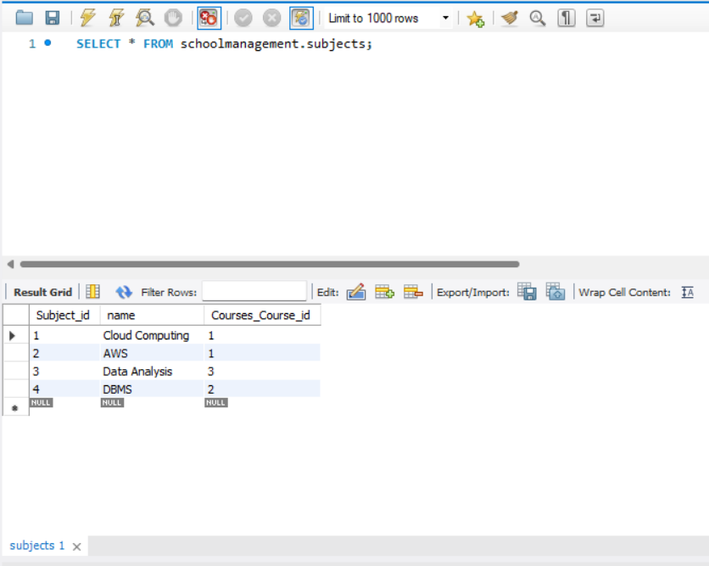

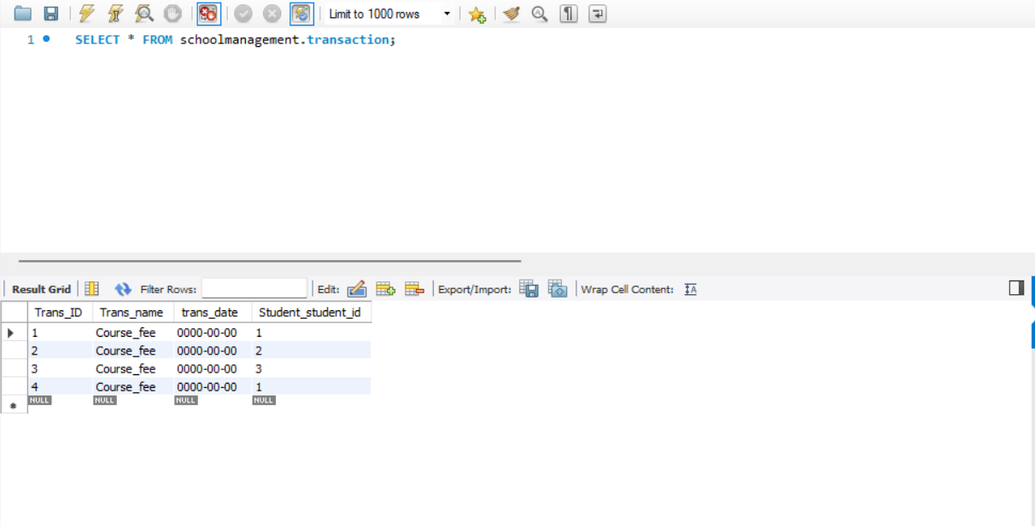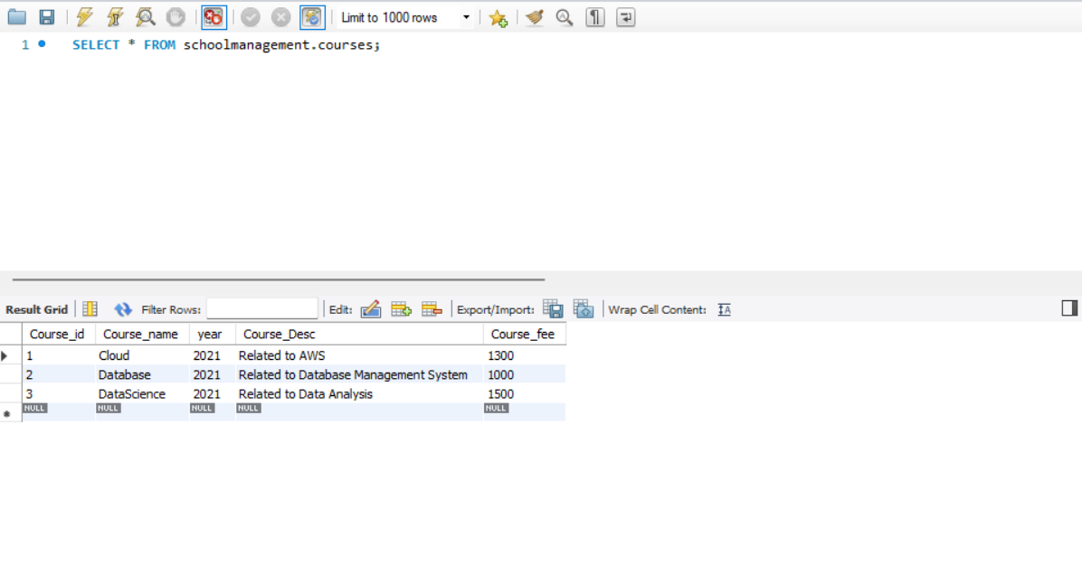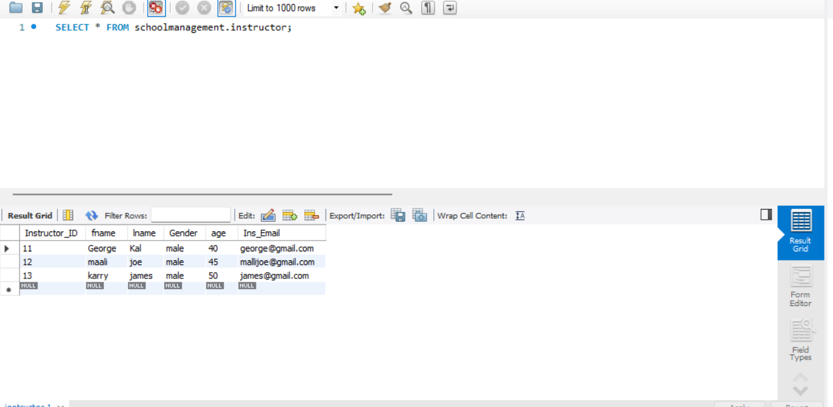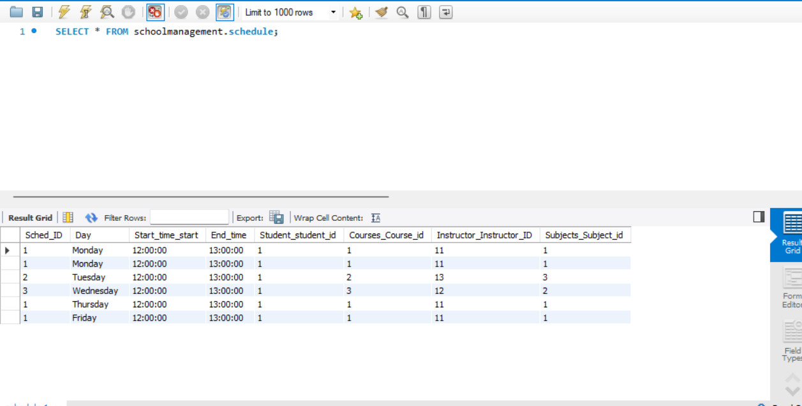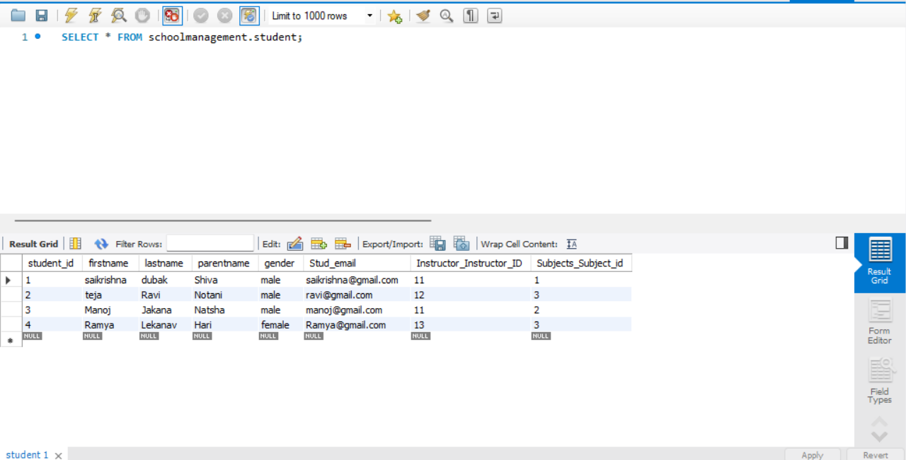

**Python Programming:**

import mysql.connector

from mysql.connector import errorcode

# Connect to the MySQL database

try:

   mydb = mysql.connector.connect(

      user="root",

      password="root",

      host="localhost",

      database="schoolmanagement")

except mysql.connector.Error as err:

   if err.errno == errorcode.ER_ACCESS_DENIED_ERROR:

      print("Invalid credentials")

   elif err.errno == errorcode.ER_BAD_DB_ERROR:

      print("Database not found")

   else:

      print("Cannot connect to database:", err)

else:

    cursor = mydb.cursor()

# Retreive all tables Infomration using the below code

    q1 = ("SELECT * FROM student")

    cursor.execute(q1)

    print("------Student Table-------\n")

    for row in cursor.fetchall():

        print(row,"\n")

    q2 = ("SELECT * FROM subjects")

    cursor.execute(q2)

    print("------Subjects Table ------------\n")

    for row in cursor.fetchall():

        print(row,"\n")

    q3 = ("SELECT * FROM courses")

    cursor.execute(q3)

    print("-----Courses Table--------\n")

    for row in cursor.fetchall():

        print(row,"\n")

    q4 = ("SELECT * FROM schedule")

    cursor.execute(q4)

    print("-----Schedule Table---------\n")

    for row in cursor.fetchall():

        print(row,"\n")

    q5 = ("SELECT * FROM transaction")

    cursor.execute(q5)

    print("-----insurance Table---------\n")

    for row in cursor.fetchall():

        print(row,"\n")

    q6 = ("SELECT * FROM instructor")

    cursor.execute(q6)

    print("-----Instructor  Table--------\n")

    for row in cursor.fetchall():

        print(row,"\n")

**Output:**

